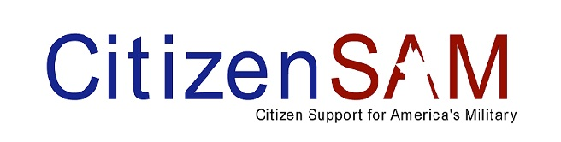

The 6th annual Operation Santa continues to gain momentum! Included in this newsletter are some newsworthy tidbits and ways you can help.
Girl Scout Cookies
What better taste of home for our men and women in uniform to receive than Girl Scout cookies. State Farm Adopt a Soldier partnered with Central Illinois Girl Scouts earlier this year in Operation Cookie Share. When the Girl Scouts throughout Central Illinois sold cookies this past spring, there was an additional column on the cookie order form marked "OCS". Folks could mark the box to buy boxes of Girl Scout cookies for our deployed heroes and Central Illinoisans responded overwhelmingly. The grand total was 98,000 boxes of Girl Scout cookies purchased by folks across Illinois were given to State Farm's Adopt a Soldier to ship to deployed troops, to military hospitals, USO hubs, and military chaplains. 25,000 boxes will go towards Operation Santa's 35,000 stockings.
Treats for Troops
Operation Santa is collecting leftover Halloween candy to include in stockings. Peoria drop offs are PNC Bank (Pioneer Parkway location only!) Busey Bank, Sheridan Rd. location, and WMBD WYZZ Fox 43 TV station on University.
Do you have a loved one who is deployed over the holidays?
Please send us his/her name, address and how many stockings to ship to info@citizensam.org. Operation Santa will be honored to include them in Santa's sleigh!
How you can help
$25 ships a box of 15 stockings. We are in great need of shipping funds. All gifts are tax deductible. Checks made out to Operation Santa can be mailed to 7131 N. Knoxville Ave., Suite C, Peoria, IL 61614. For your convenience, PayPal is located on our website www.operationsanta.info.
Thank you for helping us send a slice of home to our men and women serving overseas this holiday season!
Patti Rios-Smith, founder and executive director of Citizen SAM has been selected as one of 5 finalists (and only female) for Outstanding Hispanic for her work on behalf of the armed forces. Please vote by visiting http://theamericano.com/ and clicking on Forum 2010. Deadline for voting is October 31. Thank you.

This email was sent by Citizen Support for America's Military, 7131 N. Knoxville Ave., Suite C, Peoria, Illinois 61614, using Express Email Marketing. You were added to this list as info@citizensam.org on 6/24/2010.
Express Email Marketing supports permission-based email marketing. You can change your preferences or unsubscribe from this mailing list at any time.

